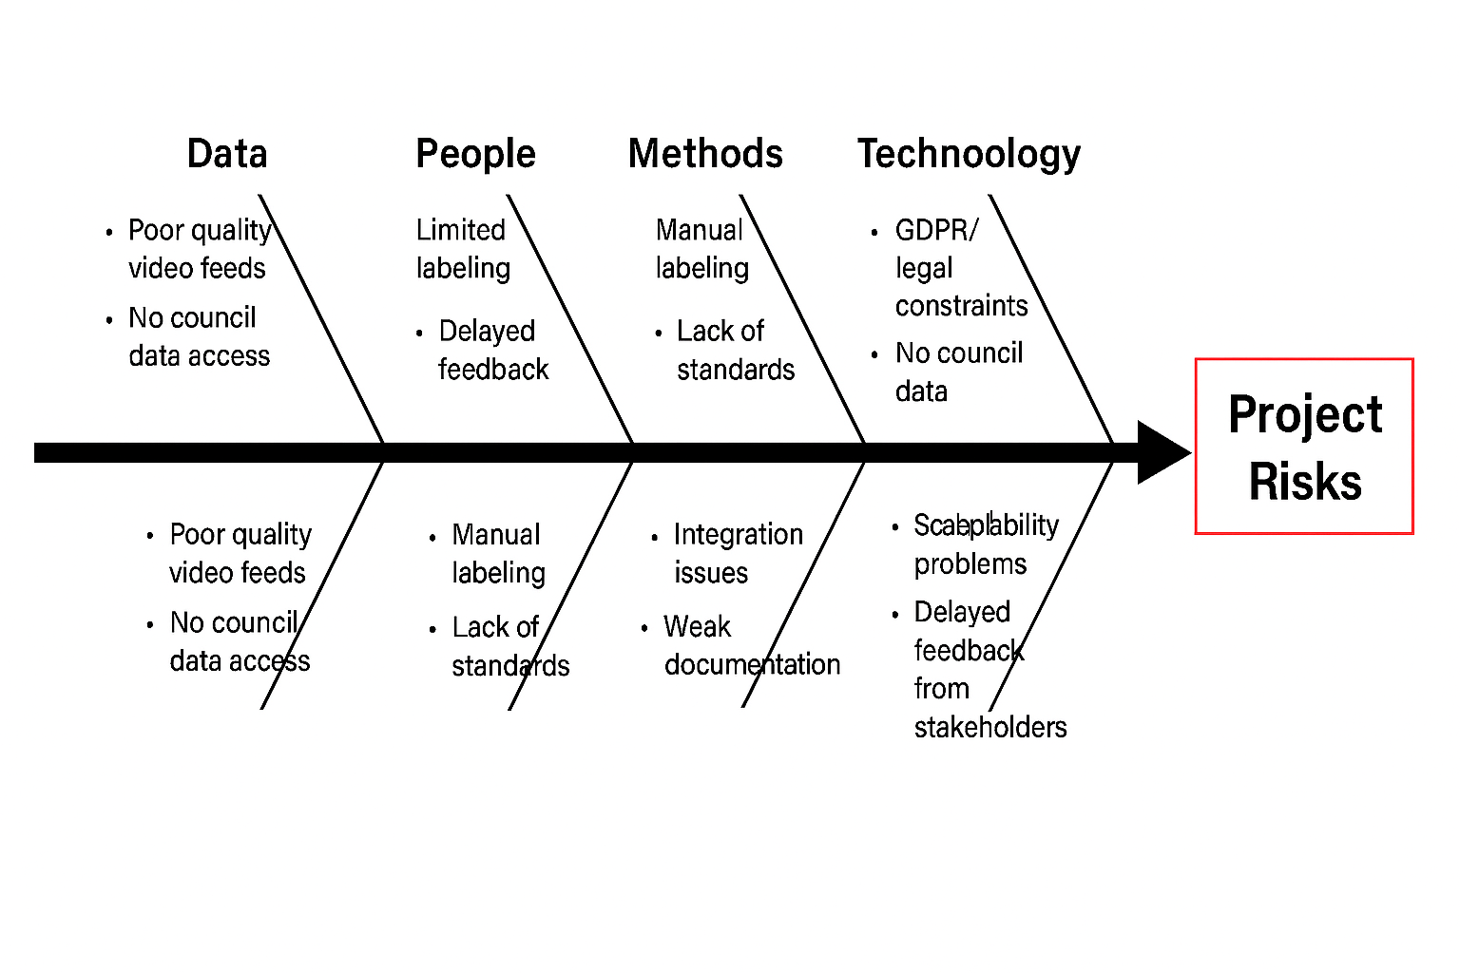

Risk Assessment Table
Risk ID | Risk Description | Impact | Likelihood | Mitigation Strategy
R1 | Privacy concerns related to data collection (GDPR compliance) | High | Medium | Ensure all data sources are anonymized and compliant with GDPR; consult council policies
R2 | Poor quality or low-resolution video data | Medium | High | Apply preprocessing filters; request higher-quality feeds from council if possible
R3 | Lack of labelled training data | High | High | Use transfer learning; explore semi-supervised methods; allocate time for manual labeling
R4 | No access to council-provided data | High | Medium | Use open datasets with similar urban context; document limitations clearly
R5 | Inconsistent environmental context in open datasets | Medium | Medium | Validate dataset relevance; adjust model parameters for generalization
R6 | Technical challenges in model training or scalability | High | Medium | Allocate buffer time; use modular architecture; consult academic advisors
R7 | Delays in stakeholder/client feedback | Medium | Medium | Schedule monthly meetings; send summaries and reminders proactively

